Task-4

**Objective:** Configure and test basic firewall rules to allow or block traffic.

Step 1: Install UFW on Kali Linux

UFW (Uncomplicated Firewall)

First, we need to install UFW since it's not installed by default on Kali:

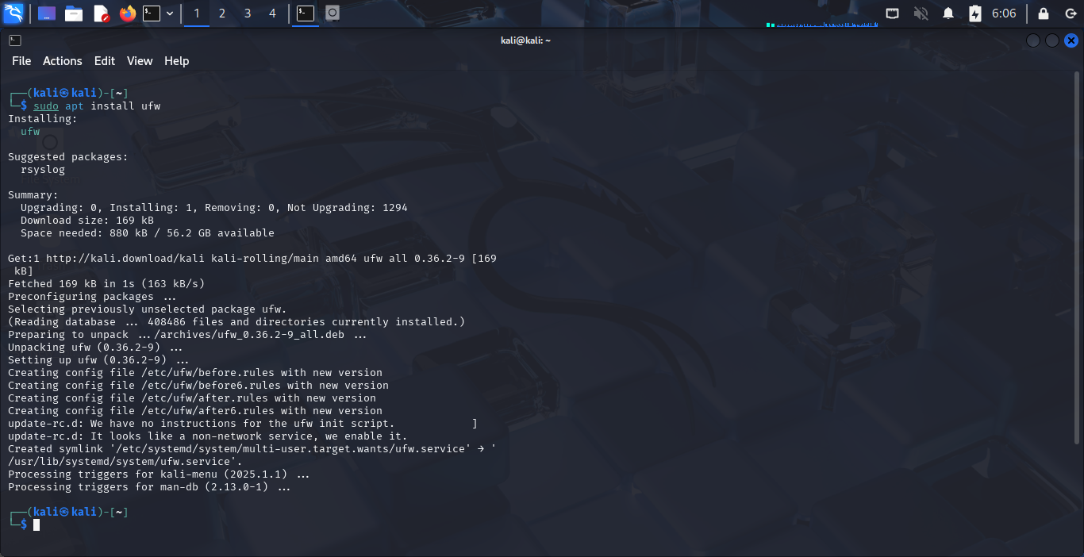

Step 2: Check UFW Status

Check if UFW is active (it should be inactive initially):

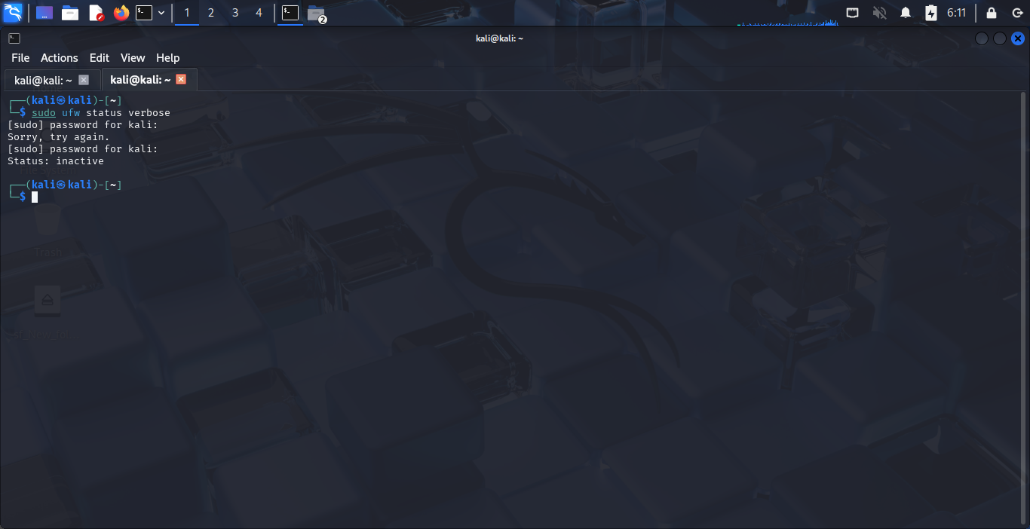

Step 3: Set Default Policies

Set default policies to deny all incoming traffic and allow all outgoing:

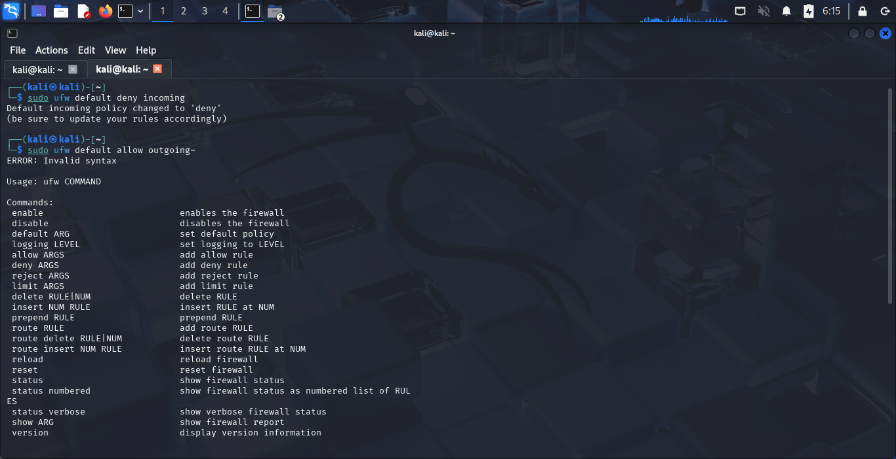

Step 4: Allow SSH (Port 22) & Block Telnet (Port 23)

Since we're working remotely, we should allow SSH first, then block Telnet as per the task requirements and enable UFW

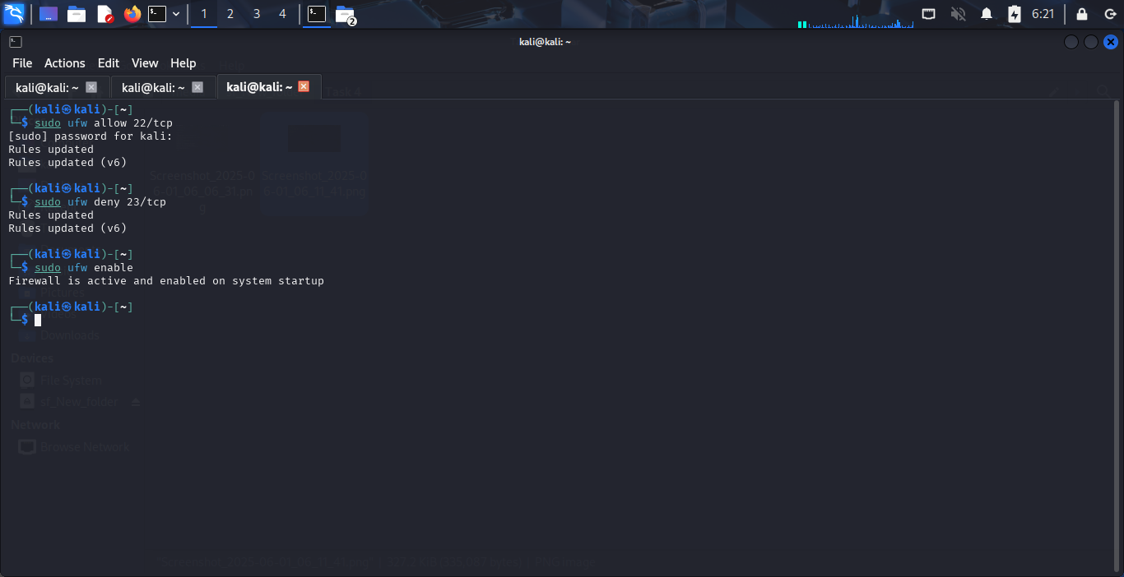

Step 5: Verify & Test Rules

Check the rules we've added and test the Telnet block

